**Institute of Technology Tralee**

**BSc. in Computing with Specialism (Group 5) - Year 1**

**Continuous Assessment #1**

**Date: 6/11/14**

**Time: 10a.m. – 12p.m.**

**Introduction to Programming**

**Instructions:** Attempt the following question. You should use the JCreator IDE for coding. When you are finished you must print out your code for correction.

**________________________________________________________**

**Q1.**

A potato grading machine is built on the following simple algorithm. It first uses an electronic “eye” to determine if the potato is good or bad. If it is bad, it does nothing else except to display a suitable message in this regard and quit immediately. If it is good, however, it then determines a maximum and a minimum diameter of the potato in millimeters (these can both be **fractional** values), calculates an average diameter and grades it according to the following table:

|  |  |
| --- | --- |
| **Average Diameter** | **Grade** |
| 0.01-24.99mm | D |
| 25-49.99mm | C |
| 50-74.99mm | B |
| 75+ | A |

Your task here is to write a program that mimics the action of the automated potato grader described above. Your program should begin by asking the user to input the condition of the potato, whether it is good or bad (say “g” for good and “b” for bad).

Provided that the potato is good, the program should then ask for the maximum and minimum diameters of the potato, calculate and display the average diameter to **2 decimal places** and display its associated grade based on the table above.

Should the potato be a bad one, the program should do nothing other than display this fact and then immediately terminate.

For full marks here your program should, along with a logically correct solution for the problem above, include **single and multi-line comments** and **meaningful variable names**. You should also aim to use **proper indentation** in the coding of the program.

Your program should run **exactly** as indicated in the following sample screenshots, with all newlines, units etc. included.

**Sample Screenshots**

**Condition of potato is good, grade turns out to be C**

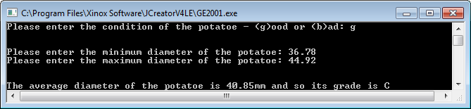

**Condition of potato is good, grade turns out to be D**

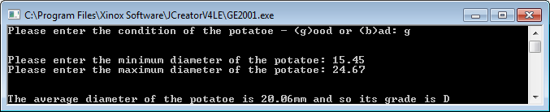

**Condition of potato is good, grade turns out to be B**

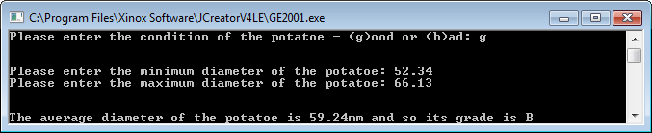

**Condition of potato is bad**

